
HOUSING PRICE PREDICTION

Submitted by:
Amrutha Dhondale

ACKNOWLEDGMENT
I would like to thank Flip Robo Technologies for providing me with the opportunity to work on this project from which I have learned a lot. I would also like to thank my mentor in Fliprobo, Swati Mahaseth, for providing me with the dataset and problem statement for performing this wonderful task.

INTRODUCTION
The objective was to model the price of houses with the available independent variables. This model can then be used by the management to understand how exactly the prices vary with the variables. They can accordingly manipulate the strategy of the firm and concentrate on areas that will yield high returns. Further, the model will be a good way for the management to understand the pricing dynamics of a new market.

BUSINESS PROBLEM FRAMING
Houses are one of the necessary needs of each and every person around the globe and therefore housing and real estate market is one of the markets which is one of the major contributors in the world’s economy. It is a very large market and there are various companies working in the domain.
Data science comes as a very important tool to solve problems in the domain to help the companies increase their overall revenue, profits, improving their marketing strategies and focusing on changing trends in house sales and purchases. Predictive modelling, Market mix modelling, recommendation systems are some of the machine learning techniques used for achieving the business goals for housing companies. Our problem is related to one such housing company.
We are required to model the price of houses with the available independent variables. This model will then be used by the management to understand how exactly the prices vary with the variables. They can accordingly manipulate the strategy of the firm and concentrate on areas that will yield high returns. Further, the model will be a good way for the management to understand the pricing dynamics of a new market
.

CONCEPTUAL BACKGROUND OF THE DOMAIN PROBLEM
A US-based housing company named Surprise Housing has decided to enter the Australian market. The company uses data analytics to purchase houses at a price below their actual values and flip them at a higher price. For the same purpose, the company has collected a data set from the sale of houses in Australia. The data is provided in the CSV file below.
The company is looking at prospective properties to buy houses to enter the market. You are required to build a model using Machine Learning in order to predict the actual value of the prospective properties and decide whether to invest in them or not. For this company wants to know:
• Which variables are important to predict the price of a variable?
• How do these variables describe the price of the house?

MOTIVATION FOR THE PROBLEM UNDERTAKEN
Our main objective of doing this project is to build a model to predict the house prices with the help of other supporting features. We are going to predict by using Machine Learning algorithms.
The sample data is provided to us from our client database. In order to improve the selection of customers, the client wants some predictions that could help them in further investment and improvement in selection of customers.
House Price Index is commonly used to estimate the changes in housing price. Since housing price is strongly correlated to other factors such as location, area, population, it requires other information apart from HPI to predict individual housing price.
There has been a considerably large number of papers adopting traditional machine learning approaches to predict housing prices accurately, but they rarely concern themselves with the performance of individual models and neglect the less popular yet complex models.
As a result, to explore various impacts of features on prediction methods, this paper will apply both traditional and advanced machine learning approaches to investigate the difference among several advanced models. This paper will also comprehensively validate multiple techniques in model implementation on regression and provide an optimistic result for housing price prediction

ANALYTICAL PROBLEM FRAMING

MATHEMATICAL/ ANALYTICAL MODELING OF THE PROBLEM
We are building a model in Machine Learning to predict the actual value of the prospective properties and decide whether to invest in them or not. So, this model will help us to determine which variables are important to predict the price of variables & also how do these variables describe the price of the house. This will help to determine the price of houses with the available independent variables. They can accordingly manipulate the strategy of the firm and concentrate on areas that will yield high returns.
Regression analysis is a set of statistical processes for estimating the relationships between a dependent variable (often called the 'outcome variable') and one or more independent variables (often called 'predictors', 'covariates', or 'features'). The most common form of regression analysis is linear regression, in which one finds the line (or a more complex linear combination) that most closely fits the data according to a specific mathematical criterion. For specific mathematical reasons this allows the researcher to estimate the conditional expectation of the dependent variable when the independent variables take on a given set of values.
Regression analysis is also a form of predictive modelling technique which investigates the relationship between a dependent (target) and independent variable (predictor). This technique is used for forecasting, time series modelling and finding the causal effect relationship between the variables.
The different Mathematical/Analytical models that are used in this project are as below:
Linear Regression, Lasso, Ridge, Elastic Net, KNeighborsRegressor, Decision Tree Regressor, RandomForest Regressor, Adaboost Regressor, GradientBoostingRegressor
First, use the train dataset and do the EDA process, fitting the best model and saving the model.
Then, use the test dataset, load the saved model and predict the values over the test data.
DATA SOURCES AND THEIR FORMATS
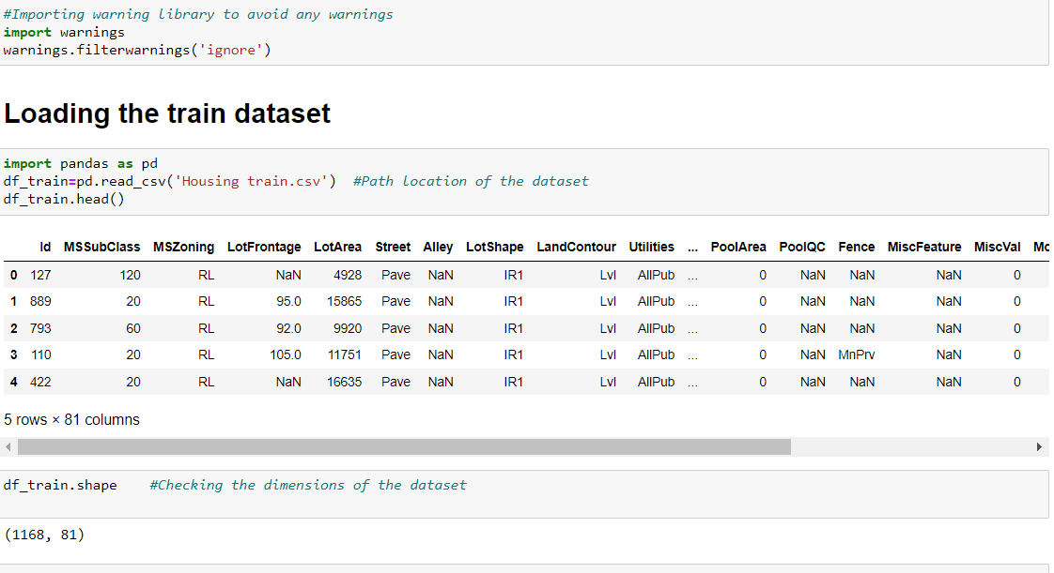
Data Description:
MSSubClass: Identifies the type of dwelling involved in the sale.
20 1-STORY 1946 & NEWER ALL STYLES 75 2-1/2 STORY ALL AGES
30 1-STORY 1945 & OLDER 80 SPLIT OR MULTI-LEVEL
40 1-STORY W/FINISHED ATTIC ALL AGES 85 SPLIT FOYER
45 1-1/2 STORY - UNFINISHED ALL AGES 90 DUPLEX - ALL STYLES AND AGES
50 1-1/2 STORY FINISHED ALL AGES 150 1-1/2 STORY PUD - ALL AGES
60 2-STORY 1946 & NEWER 160 2-STORY PUD - 1946 & NEWER
70 2-STORY 1945 & OLDER 180 PUD - MULTILEVEL - INCL SPLIT LEV/FOYER
120 1-STORY PUD (Planned Unit Development) - 1946 & NEWER
190 2 FAMILY CONVERSION - ALL STYLES AND AGES
MSZoning: Identifies the general zoning classification of the sale.
A: Agriculture C: Commercial FV:Floating Village Residential I:Industrial RH:Residential High Density
RL:Residential Low Density RP:Residential Low Density Park RM:Residential Medium Density
LotFrontage: Linear feet of street connected to property
LotArea: Lot size in square feet
Street: Type of road access to property
Grvl Gravel Pave Paved
Alley: Type of alley access to property
Grvl: Gravel Pave:Paved NA:No alley access
LotShape: General shape of property
Reg: Regular IR1: Slightly irregular IR2: Moderately Irregular IR3: Irregular
LandContour: Flatness of the property
Lvl: Near Flat/Level Bnk: Banked - Quick and significant rise from street grade to building
HLS Hillside - Significant slope from side to side Low: Depression
Utilities: Type of utilities available
AllPub: All public Utilities (E, G, W, & S) NoSewr: Electricity, Gas, and Water (Septic Tank)
NoSeWa: Electricity and Gas Only ELO: Electricity only
LotConfig: Lot configuration
Inside: Inside lot Corner: Corner lot CulDSac: Cul-de-sac FR2: Frontage on 2 sides of property
FR3 Frontage on 3 sides of property
LandSlope: Slope of property
Gtl: Gentle slope Mod: Moderate Slope Sev: Severe Slope
Neighborhood: Physical locations within Ames city limits
Blmngtn: Bloomington Heights Blueste: Bluestem BrDale: Briardale BrkSide: Brookside
ClearCr: Clear Creek CollgCr: College Creek Crawfor : Crawford Edwards:Edwards
Gilbert: Gilbert IDOTRR: Iowa DOT and Rail Road MeadowV: Meadow Village Mitchel:Mitchell
Names: North Ames NoRidge: Northridge NPkVill: Northpark Villa NridgHt: Northridge Heights
NWAmes: Northwest Ames OldTown : Old Town SWISU: South & West of Iowa State University
Sawyer: Sawyer SawyerW: Sawyer West Somerst: Somerset StoneBr: Stone Brook
Timber: Timberland Veenker: Veenker
Condition1: Proximity to various conditions
Artery: Adjacent to arterial street Feedr: Adjacent to feeder street Norm: Normal
RRNn: Within 200' of North-South Railroad RRAn: Adjacent to North-South Railroad
PosN: Near positive off-site feature--park, greenbelt, etc.
PosA: Adjacent to postive off-site feature RRNe: Within 200' of East-West Railroad
RRAe: Adjacent to East-West Railroad
Condition2: Proximity to various conditions (if more than one is present)
Artery: Adjacent to arterial street Feedr: Adjacent to feeder street Norm: Normal
RRNn: Within 200' of North-South Railroad RRAn: Adjacent to North-South Railroad
PosN: Near positive off-site feature--park, greenbelt, etc. PosA: Adjacent to postive off-site feature
RRNe: Within 200' of East-West Railroad RRAe: Adjacent to East-West Railroad
BldgType: Type of dwelling
1Fam: Single-family Detached 2FmCon: Two-family Conversion; originally built as one-family dwelling
Duplx: Duplex TwnhsE: Townhouse End Unit TwnhsI: Townhouse Inside Unit
HouseStyle: Style of dwelling
1Story: One story 1.5Fin: One and one-half story: 2nd level finished
1.5Unf: One and one-half story: 2nd level unfinished 2Story: Two story
2.5Fin: Two and one-half story: 2nd level finished 2.5Unf: Two and one-half story: 2nd level unfinished
SFoyer Split Foyer SLvl Split Level
OverallQual: Rates the overall material and finish of the house
10 Very Excellent 9 Excellent 8 Very Good 7 Good 6 Above Average
5 Average 4 Below Average 3 Fair 2 Poor 1 Very Poor
OverallCond: Rates the overall condition of the house
10 Very Excellent 9 Excellent 8 Very Good 7 Good 6 Above Average
5 Average 4 Below Average 3 Fair 2 Poor 1 Very Poor
YearBuilt: Original construction date
YearRemodAdd: Remodel date (same as construction date if no remodeling or additions)
RoofStyle: Type of roof
Flat: Flat Gable: Gable Gambrel: Gabrel (Barn) Hip: Hip Mansard: Mansard Shed: Shed
RoofMatl: Roof material
ClyTile: Clay or Tile CompShg: Standard (Composite) Shingle Membran: Membrane
Metal: Metal Roll: Roll Tar&Grv: Gravel & Tar WdShake: Wood Shakes WdShngl: Wood Shingles
Exterior1st: Exterior covering on house
AsbShng Asbestos Shingles AsphShn Asphalt Shingles BrkComm Brick Common
BrkFace: Brick Face CBlock: Cinder Block CemntBd Cement Board HdBoard: Hard Board
ImStucc: Imitation Stucco MetalSd Metal Siding Other Other Plywood Plywood
PreCast PreCast Stone: Stone Stucco: Stucco VinylSd: Vinyl Siding
Wd Sdng Wood Siding WdShing Wood Shingles
Exterior2nd: Exterior covering on house (if more than one material)
AsbShng Asbestos Shingles AsphShn Asphalt Shingles BrkComm Brick Common
BrkFace: Brick Face CBlock: Cinder Block CemntBd Cement Board HdBoard Hard Board
ImStucc Imitation Stucco MetalSd Metal Siding Other: ther Plywood Plywood
PreCast PreCast Stone Stone Stucco Stucco VinylSd: Vinyl Siding Wd Sdng Wood Siding
WdShing Wood Shingles
MasVnrType: Masonry veneer type
BrkCmn Brick Common BrkFace Brick Face CBlock Cinder Block None None
Stone Stone
MasVnrArea: Masonry veneer area in square feet
ExterQual: Evaluates the quality of the material on the exterior
Ex Excellent Gd Good TA Average/Typical Fa Fair Po Poor
ExterCond: Evaluates the present condition of the material on the exterior
Ex Excellent Gd Good TA Average/Typical Fa Fair Po Poor
Foundation: Type of foundation
BrkTil Brick & Tile CBlock Cinder Block PConc Poured Contrete
Slab Slab Stone Stone Wood Wood
BsmtQual: Evaluates the height of the basement
Ex Excellent (100+ inches) Gd Good (90-99 inches) TA Typical (80-89 inches)
Fa Fair (70-79 inches) Po Poor (<70 inches) NA No Basement
BsmtCond: Evaluates the general condition of the basement
Ex Excellent (100+ inches) Gd Good (90-99 inches) TA Typical (80-89 inches)
Fa Fair (70-79 inches) Po Poor (<70 inches) NA No Basement
BsmtExposure: Refers to walkout or garden level walls
Gd Good Exposure Av Average Exposure (split levels or foyers typically score average or above)
Mn Mimimum Exposure No No Exposure NA No Basement
BsmtFinType1: Rating of basement finished area
GLQ Good Living Quarters ALQ Average Living Quarters BLQ Below Average Living Quarters
Rec Average Rec Room LwQ Low Quality Unf Unfinshed NA No Basement
BsmtFinSF1: Type 1 finished square feet
BsmtFinType2: Rating of basement finished area (if multiple types)
GLQ Good Living Quarters ALQ Average Living Quarters BLQ Below Average Living Quarters
Rec Average Rec Room LwQ Low Quality Unf Unfinshed NA No Basement
BsmtFinSF2: Type 2 finished square feet
BsmtUnfSF: Unfinished square feet of basement area
TotalBsmtSF: Total square feet of basement area
Heating: Type of heating
Floor: Floor Furnace GasA: Gas forced warm air furnace GasW: Gas hot water or steam heat
Grav Gravity furnace OthW: Hot water or steam heat other than gas Wall Wall furnace
HeatingQC: Heating quality and condition
Ex Excellent Gd Good TA Average/Typical Fa Fair Po Poor
CentralAir: Central air conditioning
N No Y Yes
Electrical: Electrical system
SBrkr Standard Circuit Breakers & Romex
FuseA Fuse Box over 60 AMP and all Romex wiring (Average)
FuseF 60 AMP Fuse Box and mostly Romex wiring (Fair)
FuseP 60 AMP Fuse Box and mostly knob & tube wiring (poor)
Mix Mixed
1stFlrSF: First Floor square feet
2ndFlrSF: Second floor square feet
LowQualFinSF: Low quality finished square feet (all floors)
GrLivArea: Above grade (ground) living area square feet
BsmtFullBath: Basement full bathrooms
BsmtHalfBath: Basement half bathrooms
FullBath: Full bathrooms above grade
HalfBath: Half baths above grade
Bedroom: Bedrooms above grade (does NOT include basement bedrooms)
Kitchen: Kitchens above grade
KitchenQual: Kitchen quality
Ex Excellent Gd Good TA Typical/Average Fa Fair Po Poor
TotRmsAbvGrd: Total rooms above grade (does not include bathrooms)
Functional: Home functionality (Assume typical unless deductions are warranted)
Typ Typical Functionality
Min1: Minor Deductions 1 Min2: Minor Deductions 2 Mod: Moderate Deductions
Maj1: Major Deductions 1 Maj2: Major Deductions 2 Sev: Severely Damaged Sal: Salvage only
Fireplaces: Number of fireplaces
FireplaceQu: Fireplace quality
Ex Excellent - Exceptional Masonry Fireplace
Gd Good - Masonry Fireplace in main level
TA Average - Prefabricated Fireplace in main living area or Masonry Fireplace in basement
Fa Fair - Prefabricated Fireplace in basement
Po Poor - Ben Franklin Stove NA No Fireplace
GarageType: Garage location
2Types More than one type of garage
Attchd Attached to home Basment Basement Garage
BuiltIn Built-In (Garage part of house - typically has room above garage)
CarPort Car Port Detchd Detached from home NA No Garage
GarageYrBlt: Year garage was built
GarageFinish: Interior finish of the garage
Fin Finished RFn Rough Finished Unf Unfinished NA No Garage
GarageCars: Size of garage in car capacity
GarageArea: Size of garage in square feet
GarageQual: Garage quality
Ex:Excellent Gd:Good TA Typical/Average Fa:Fair Po:Poor NA: No Garage
GarageCond: Garage condition
Ex:Excellent Gd:Good TA:Typical/Average Fa:Fair Po:Poor NA:No Garage
PavedDrive: Paved driveway
Y Paved P Partial Pavement N Dirt/Gravel
WoodDeckSF: Wood deck area in square feet
OpenPorchSF: Open porch area in square feet
EnclosedPorch: Enclosed porch area in square feet
3SsnPorch: Three season porch area in square feet
ScreenPorch: Screen porch area in square feet
PoolArea: Pool area in square feet
PoolQC: Pool quality
Ex Excellent Gd Good TA Average/Typical Fa Fair NA No Pool
Fence: Fence quality
GdPrv Good Privacy MnPrv Minimum Privacy
GdWo Good Wood MnWw Minimum Wood/Wire NA No Fence
MiscFeature: Miscellaneous feature not covered in other categories
Elev Elevator Gar2 2nd Garage (if not described in garage section)
Othr Other Shed Shed (over 100 SF) TenC Tennis Court NA None
MiscVal: $Value of miscellaneous feature
MoSold: Month Sold (MM)
YrSold: Year Sold (YYYY)
SaleType: Type of sale
WD Warranty Deed - Conventional CWD Warranty Deed - Cash
VWD Warranty Deed - VA Loan New Home just constructed and sold
COD Court Officer Deed/Estate Con Contract 15% Down payment regular terms
ConLw Contract Low Down payment and low interest ConLI Contract Low Interest
ConLD Contract Low Down Oth Other
SaleCondition: Condition of sale
Normal Normal Sale Abnorml Abnormal Sale - trade, foreclosure, short sale
AdjLand Adjoining Land Purchase
Alloca Allocation - two linked properties with separate deeds, typically condo with a garage unit
Family Sale between family members
Partial Home was not completed when last assessed (associated with New Homes)
DATA PREPROCESSING
Data pre-processing in Machine Learning refers to the technique of preparing (cleaning and organizing) the raw data to make it suitable for a building and training Machine Learning models. In other words, whenever the data is gathered from different sources it is collected in raw format which is not feasible for the analysis. Data pre-processing is an integral step in Machine Learning as the quality of data and the useful information that can be derived from it directly affects the ability of our model to learn; therefore, it is extremely important that we pre- process our data before feeding it into our model.
CHECKING THE NUMBER OF NULL VALUES IN THE DATASET
CHECKING THE PERCENTAGE OF MISSING DATA

HARDWARE AND SOFTWARE REQUIREMENTS AND TOOLS USED
HARDWARE:
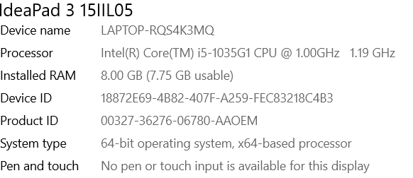
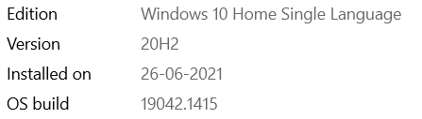

SOFTWARE:
Jupyter Notebook (Anaconda 3) – Python 3.8.5

LIBRARIES:
The tools, libraries and packages we used for accomplishing this project are pandas, numpy, matplotlib, seaborn, scipy stats, sklearn.decomposition pca, sklearn standardscaler, GridSearchCV, joblib.
import numpy as np
import seaborn as sns
import matplotlib.pyplot as plt
from sklearn.preprocessing import LabelEncoder
from scipy.stats import zscore
from sklearn.preprocessing import StandardScaler
from sklearn.decomposition import PCA
from sklearn.model_selection import train_test_split
from sklearn.linear_model import LinearRegression
from sklearn.metrics import r2_score
from sklearn.linear_model import LinearRegression,Lasso,Ridge,ElasticNet
from sklearn.svm import SVR
from sklearn.neighbors import KNeighborsRegressor
from sklearn.tree import DecisionTreeRegressor
from sklearn.metrics import mean_absolute_error,mean_squared_error
from sklearn.model_selection import cross_val_score
from sklearn.model_selection import GridSearchCV
from sklearn.ensemble import RandomForestRegressor
from sklearn.ensemble import AdaBoostRegressor
from sklearn.ensemble import GradientBoostingRegressor

MODEL/S DEVELOPMENT AND EVALUATION

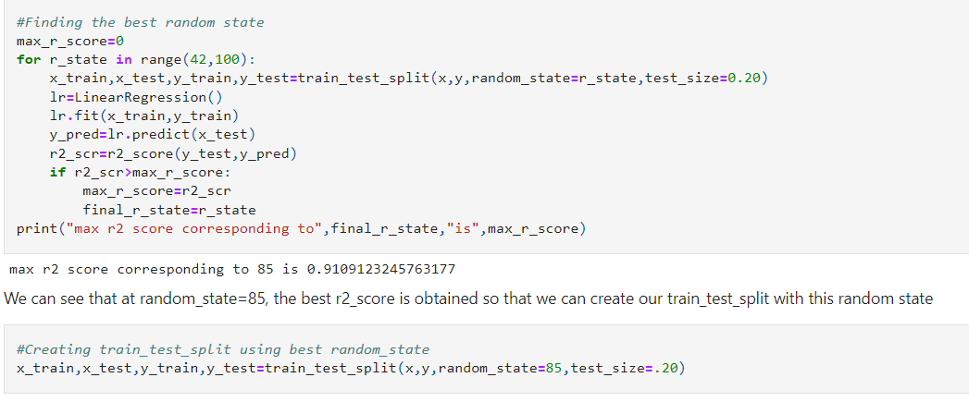
RUN AND EVALUATE SELECTED MODELS

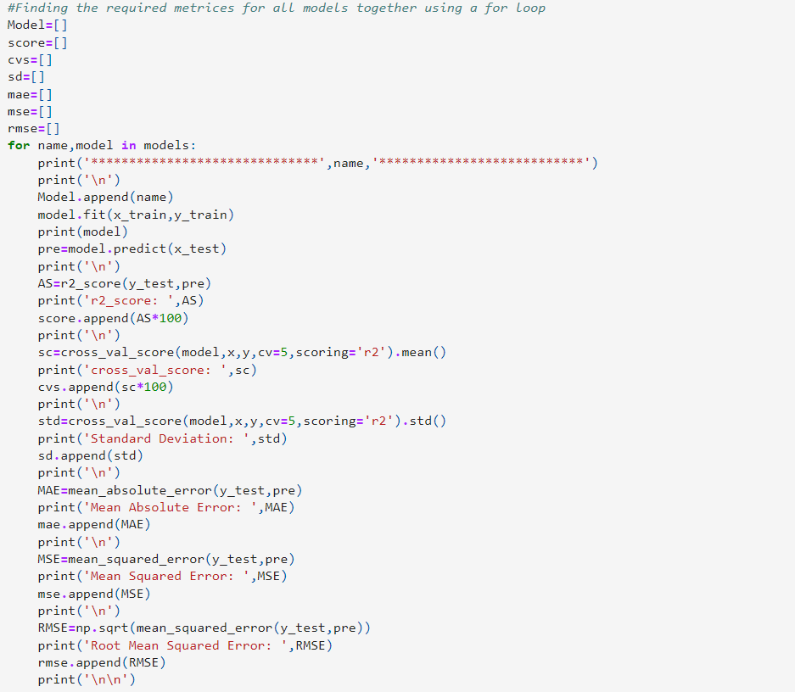

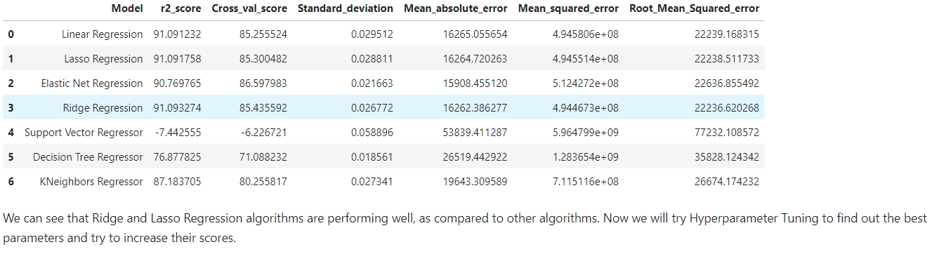

HYPERPARAMETER TUNING

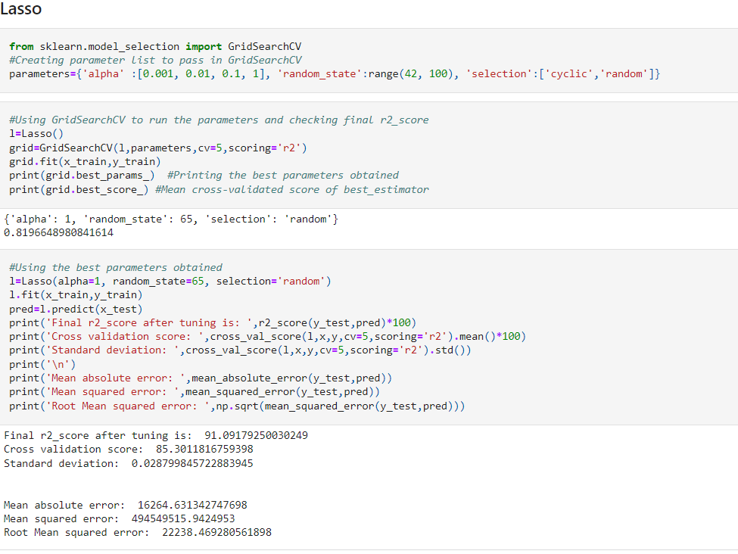
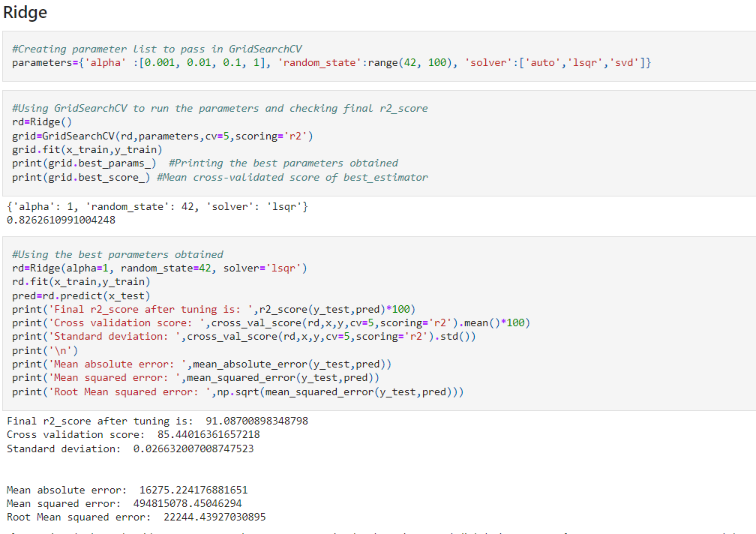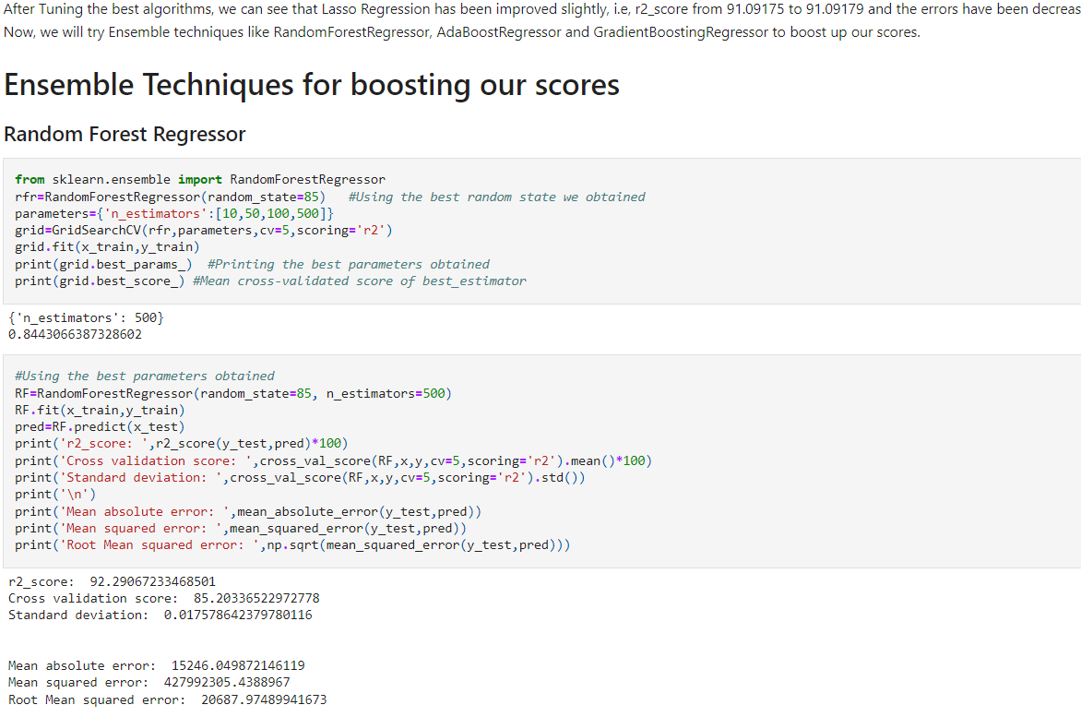
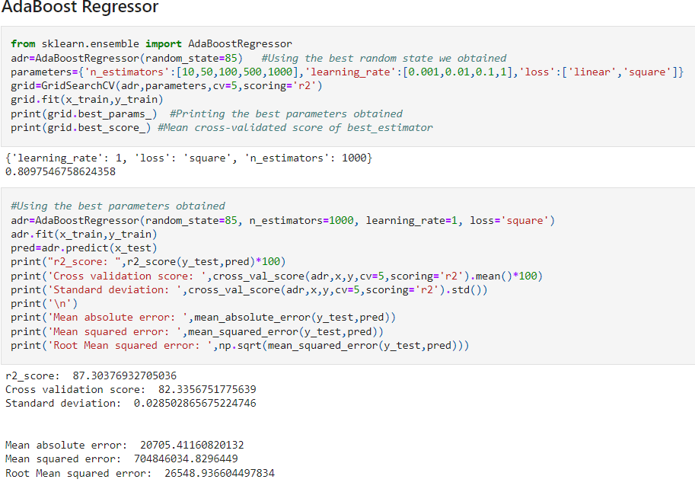
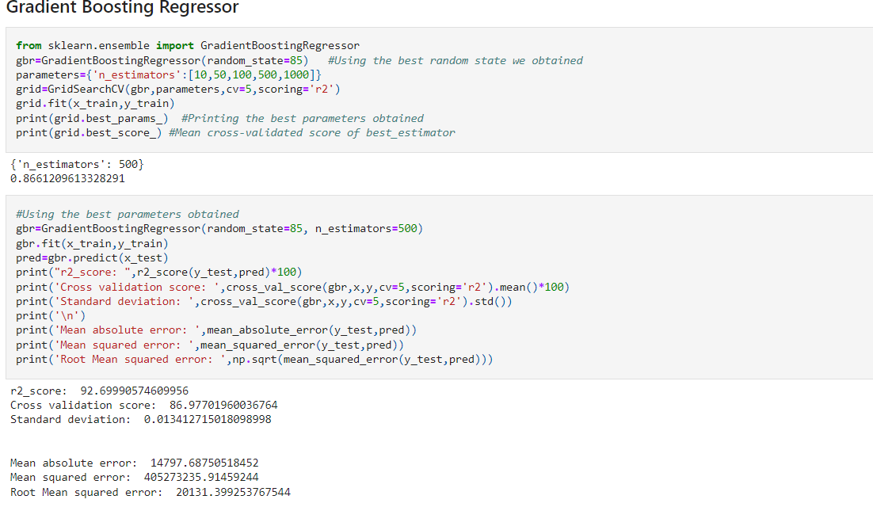
KEY METRICS FOR SUCCESS IN SOLVING PROBLEM UNDER CONSIDERATION
After applying Ensemble Techniques, we can see that Gradient Boosting Regressor is the best performing algorithm among all other algorithms as it is giving a r2_score of 92.69 and cross validation score of 86.97. It has also the less amount of error values obtained. Lesser the RMSE score, the better the model. Now we will finalize the model.

VISUALIZATION
Below technique was used for data visualization
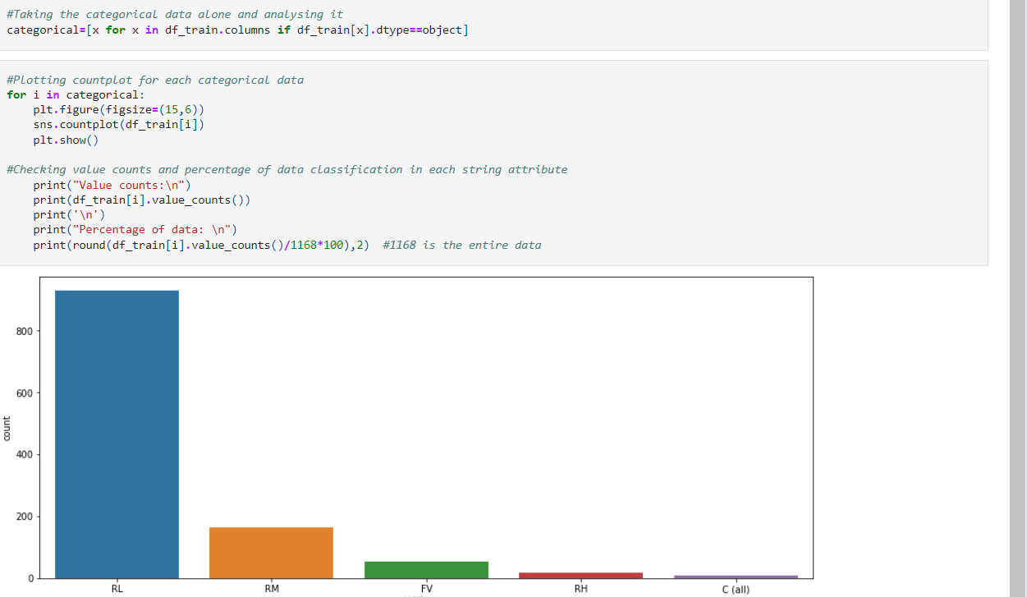
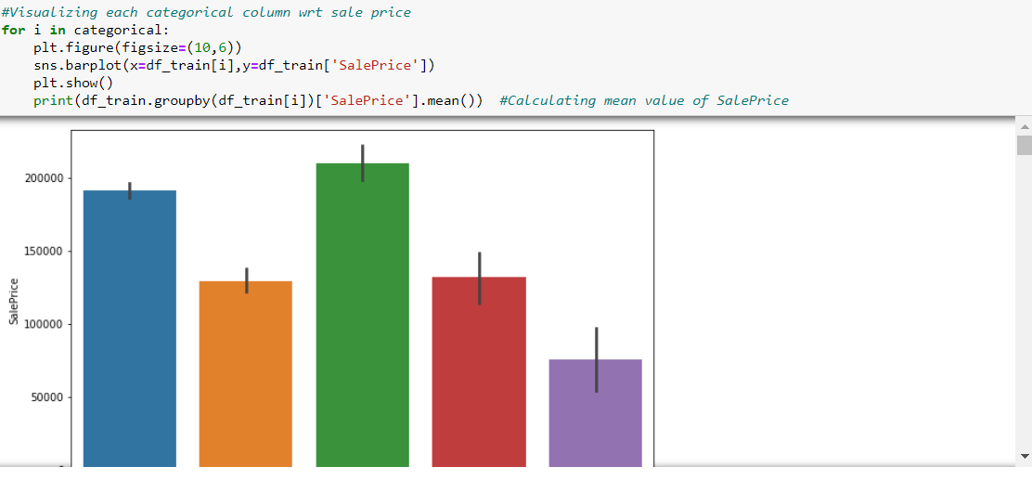
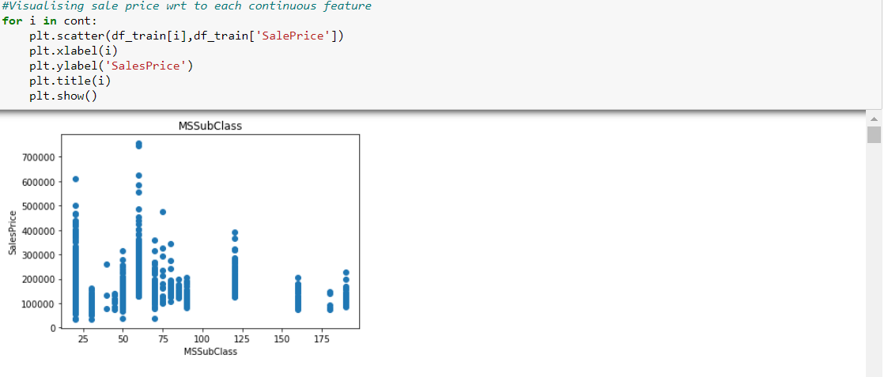
CONCLUSION
After getting an insight of this dataset, we were able to understand that the Housing prices are done on basis of different features.
First, we loaded the train dataset and did the EDA process and other pre-processing techniques like skewness check and removal, handling the outliers present, filling the missing data, visualizing the distribution of data, etc.
Then we did the model training, building the model and finding out the best model on the basis of different metrices scores we got like Mean Absolute Error, Mean squared Error, Root Mean Squared Error, etc.
We got Lasso Regressor as the best algorithm among all as it gave more r2_score and cross_val_score. Then for finding out the best parameter and improving the scores, we performed Hyperparameter Tuning.
As the scores were not increased, we also tried using Ensemble Techniques like RandomForestRegressor, AdaBoostRegressor and GradientBoostingRegressor algorithms for boosting up our scores. Finally, we concluded that GradientBoostingRegressor was the best performing algorithm, although there were more errors in it and it had less RMSE compared to other algorithms. It gave an r2_score of 92.27 and cross_val_score of 86.91 which is the highest scores among all.
We saved the model in a pickle with a filename in order to use whenever we require.
We predicted the values obtained and saved it separately in a csv file.
Then we used the test dataset and performed all the pre-processing pipeline methods to it.

LIMITATIONS OF THIS WORK AND SCOPE FOR FUTURE WORK
1. The biggest limitation I observed was that not all categories of a particular feature were available in the training data. So, if there were new category in the test data the model would not be able to identify that.
Example: MSZoning has 8 categories
A Agriculture
C Commercial
FV Floating Village Residential
I Industrial
RH Residential High Density
RL Residential Low Density
RP Residential Low-Density Park
RM Residential Medium Density
2. However in the Training dataset only 5 categories are present, what happen if other 3 categories will present in test data in future. It would be difficult for machine to identify and predict.
3. The high skewness of data reduces the effectivity
4.Many features have NaN values more than 50%, and imputation of them can decrease the effectiveness. And dropping them had the loss of data.
5.we can increase the efficiency of a model by selecting a better method to remove outliers and skewness also how to make the search of perfect model in a way that if we want to change some parameters in model then we don't have to run all the model again

THANK YOU.

